Working in the Cloud

with ClearMedia Academy

ClearMedia All-In-One deployment

**Disclaimer**:

By using the ClearMedia vCloud Director templates, you can greatly reduce the amount of time needed to deploy new VMs. These templates have been configured with the best practices in mind, to assure optimal stability and performance. Although use of the template is not compulsory, it is recommended!

This guide assumes you are building a new vApp based on Template version 1.4 and deploying the template from the “Catalog” tab with a single server setup or “All-In-One” (AIO).

In-Depth explanation and step-by-step procedures

* We assume that you have started from the VMware Template 1.4 v4 Document.
* Log-on to the Windows server and navigate to the folder C:\iNSTALL\ .
* Right click on “SyncGit.ps1” and choose “Run with powershell” to sync with the GitHub repo.

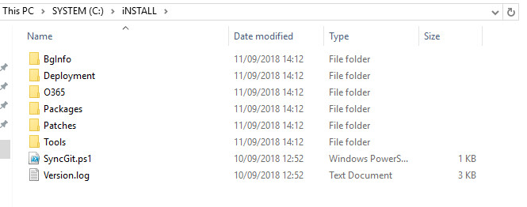

* Log-on to the Windows server and navigate to the folder C:\iNSTALL\deployment\AioSetup\ .

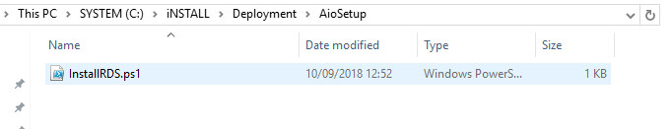

* Run the “InstallRDS.ps1” script on the server by right clicking on it and choose “Run with PowerShell”. This will install all the necessary modules.
* You do not need to answer any questions or insert any parameters. Just execute it.
* If you want to know what the script does, just open it with a text editor.

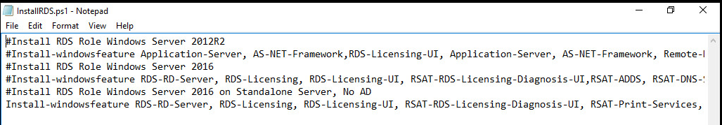

* The script will take about a minute the run. At the end of the script, the server will reboot.
* Next step is roll out the Office365 and/or F-Secure Antivirus agent, which is covered in the next modules.
* Finished!